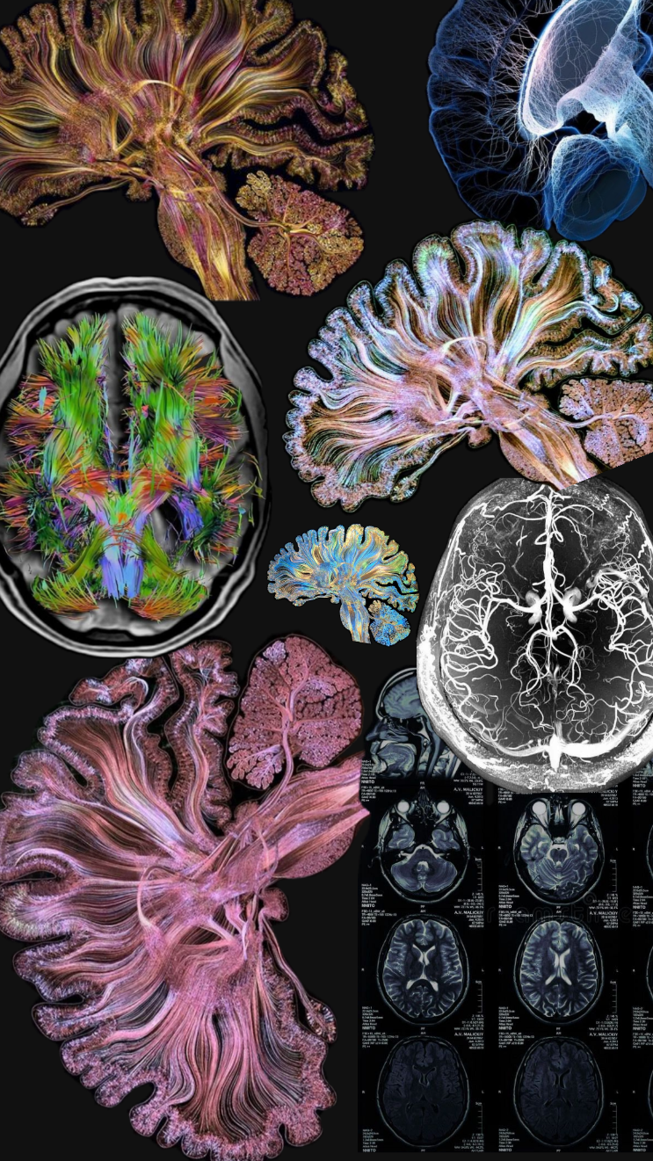

Functional Connectivity Analysis of EEG Signals Using Wavelet Coherence

SARA SHAHAMA V P| 01-11-2025

# **INTRODUCTION**

Understanding how different regions of the brain communicate and coordinate during various mental tasks is a fundamental question in neuroscience. Electroencephalography (EEG) provides a non-invasive way to record brain activity with excellent temporal resolution, making it a valuable tool for studying brain connectivity. Functional connectivity refers to the statistical relationships between signals recorded from different brain areas, reflecting how these areas interact dynamically.

In this project, the focus is on estimating and analyzing functional connectivity patterns in EEG data using wavelet coherence. Wavelet coherence is a powerful method that captures frequency-specific synchrony between brain signals over time, which is particularly relevant since neural communication often occurs through oscillatory activity in specific frequency bands, such as the alpha band (8–13 Hz).

The main problem addressed here is how to quantify and compare these dynamic interactions during different cognitive states—in this case, resting and motor imagery—across multiple subjects. By applying wavelet coherence, the goal is to extract meaningful connectivity patterns and statistically evaluate their differences between conditions.

This work matters because insights into brain functional connectivity have broad implications, from understanding basic brain function to developing clinical applications like brain-computer interfaces and diagnosing neurological disorders. Reliable methods to detect connectivity changes can open doors to better interpreting brain dynamics and tailoring interventions.

The report will detail the data processing steps, the application of wavelet coherence to extract connectivity, the statistical frameworks used to test differences, and the interpretation of the results in the context of brain network dynamics.

# **METHODOLOGY**

Data Source

The EEG data used in this project were obtained from the publicly available PhysioNet Motor Movement/Imagery Dataset. It contains recordings from healthy adult participants performing two conditions — a resting baseline and motor imagery tasks.

For this study, I focused on the first five subjects and specifically analyzed two runs: Run 1 (rest) and Run 4 (motor imagery).

Preprocessing and Channel Selection

EEG preprocessing was carried out using the MNE-Python toolbox. To target brain areas involved in motor and cognitive processing, we selected seven electrodes:

C3, Cz, C4, Fz, Pz, P3, and P4.

Preprocessing steps included:

Notch filtering (50 Hz) to remove power line noise and harmonics.

Bandpass filtering (1–40 Hz) to isolate brain-relevant frequencies.

Downsampling to 128 Hz to reduce data size and computational load.

Epoching into non-overlapping 2-second segments for stationarity.

Detrending to remove slow drifts from each epoch.

These steps ensured the EEG data were clean, temporally stable, and ready for frequency-domain analysis.

Functional Connectivity Analysis using Wavelet Coherence

To capture frequency-specific synchrony between brain regions, Morlet wavelet transforms were applied to each epoch, producing time–frequency representations between 4 Hz and 30 Hz.

Wavelet coherence was then computed between all pairs of channels, quantifying the degree of coupling at each frequency and time point.

I focused on the alpha band (8–13 Hz), known to reflect motor imagery and resting-state processes.

For each subject and condition:

Coherence values were averaged across epochs and frequencies within the alpha range.

The result was a 7 × 7 coherence matrix representing the functional connectivity strength between the selected EEG channels.

Statistical Analysis

To assess condition-related differences in connectivity:

1. Upper-triangular edges from the coherence matrices were extracted for each subject.

2. Paired t-tests were performed for each edge, comparing motor imagery versus rest conditions.

3. False Discovery Rate (FDR) correction was applied to control for multiple comparisons.

4. Network-Based Statistics (NBS) with permutation testing was used to detect connected subnetworks showing significant changes.

Additionally, Cohen’s d effect sizes were computed to quantify the magnitude of differences in coherence strength.

Visualization

Significant edges and subnetworks identified by NBS were visualized as functional connectivity graphs.

Nodes represented EEG channels.

Edges were weighted by test statistics or effect sizes.

When possible, electrode positions were arranged according to the 10–20 system montage; otherwise, circular layouts were used for clarity.

These visualizations highlighted connectivity patterns and regional interactions distinguishing motor imagery from resting states.

# **RESULT**

The analysis focused on comparing alpha-band functional connectivity between resting and motor imagery conditions in five subjects, using wavelet coherence across seven EEG channels.

Alpha Coherence Matrices

For each subject and condition, alpha coherence matrices were calculated, capturing the strength of synchronization between channel pairs. An example matrix for Subject 3 during motor imagery showed a range of coherence values between electrode pairs, illustrating varying degrees of functional connectivity across electrodes

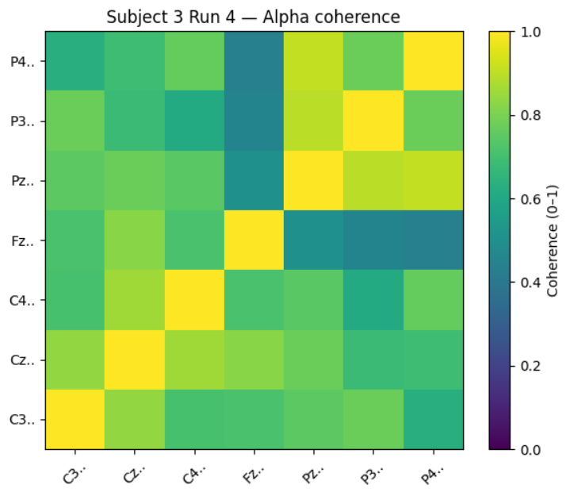

Edge-wise Statistical Testing

Paired t-tests were performed on coherence values for each edge (channel pair) to assess differences between conditions. Multiple comparison corrections via False Discovery Rate (FDR) were applied.

No edges passed FDR correction, indicating no statistically robust differences at the individual connection level across subjects

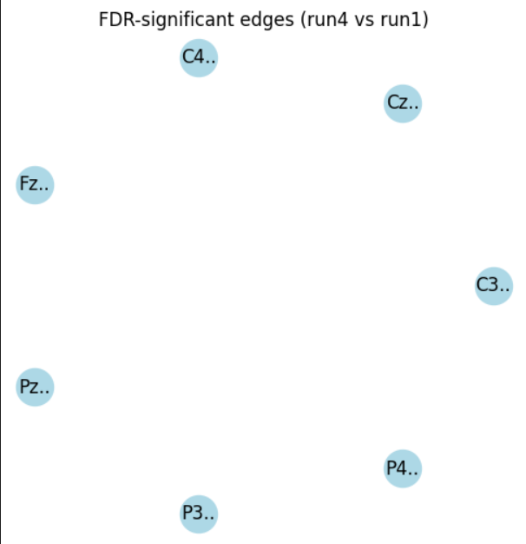

The top edges by raw effect size, such as between Fz and P4, showed moderate effects (Cohen’s d ranging around 1.28), but none were deemed significant after correction.

Network-Based Statistics (NBS)

To look for groups of connected edges showing consistent differences, NBS was applied:

The largest network component contained only a single edge (between Fz and P4) with a size of 1 edge.

The permutation-based p-value was 0.343, indicating that such a component size frequently appears by chance.

This confirms no significant subnetworks of connectivity changes were detected (Figure 3).

Visualizations

Network graphs of significant edges and NBS subnetworks were generated using estimated electrode locations.

The FDR-significant graph showed isolated nodes without connections, reflecting no significant edges



The NBS graph highlighted the one-edge component but with a non-significant p-value

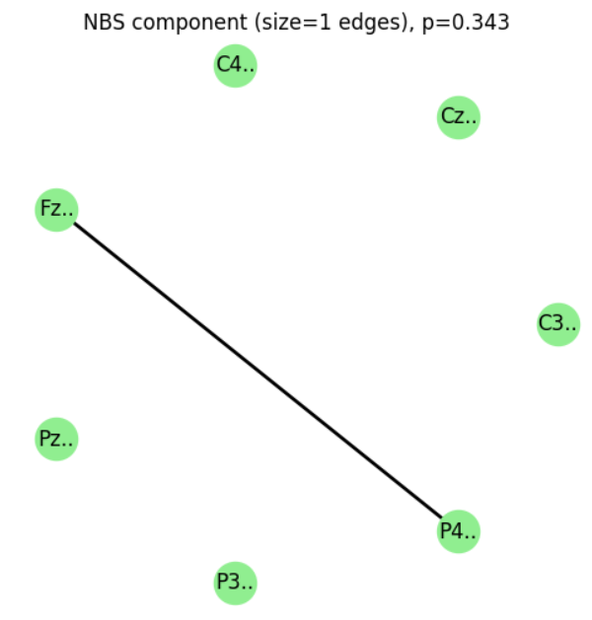

Interpretation

While raw effect sizes suggest some connectivity differences between conditions, we did not find statistically significant changes after rigorous correction for multiple testing. The lack of significant edges or subnetworks may be due to the modest sample size, variability across subjects, or subtle connectivity changes. These results still provide valuable insights and a framework for future studies with larger samples. The wavelet coherence method proved effective in estimating frequency-specific connectivity suitable for these analyses.

# **CONCLUSION**

Overall, this project has provided valuable insights into the neural connectivity patterns associated with resting and motor imagery states. By applying wavelet coherence analysis, I successfully estimated how different brain regions communicate in the alpha band, which is known to be relevant for motor tasks and cognitive processes.

While the statistical tests did not find significant differences after correcting for multiple comparisons, the observed effects suggest there are subtle connectivity changes worth exploring further. The methods and analyses employed—ranging from time-frequency decomposition to network-level testing—demonstrate a robust framework for investigating brain dynamics.

Looking ahead, increasing the sample size or focusing on specific brain regions could help uncover more pronounced effects. The approaches developed here have broad potential for advancing brain-computer interface applications, understanding neurological conditions, and exploring brain function in health and disease.

This effort has laid the groundwork for deeper exploration into brain connectivity, and I am optimistic that with continued research, I can uncover meaningful patterns that contribute to our understanding of the brain’s complex communication networks.